KUK Solutions Site BRD:
Task 1: When I click on Next or Previous buttons on each, it should display respective pages and at the same time, in the side bar same topic should highlight.
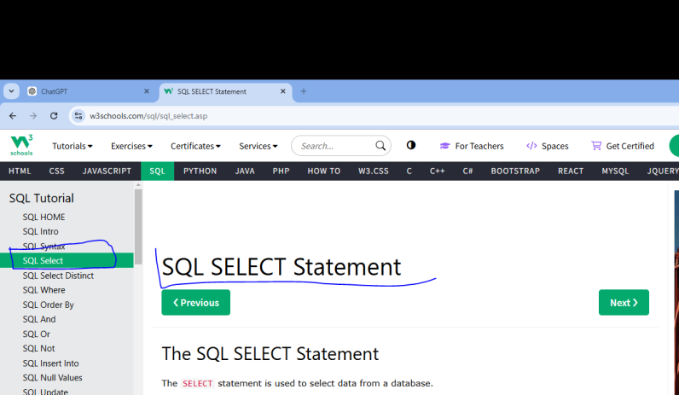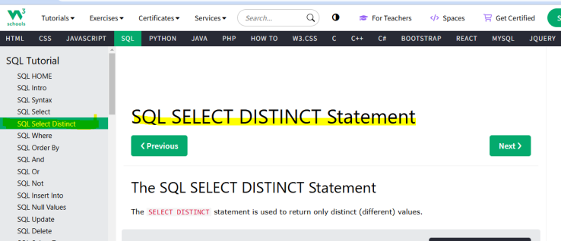

Topic | Previous Button | Next Button
select | Sql Language | Select Distinct
Select Distinct | select | where
where | Select Distinct | Group By
Group By | where | Having
Having | Group By | Order By
Order By | Having | Null
Null | Order By | Create Table
Create Table | Null | Alter Table
Alter Table | Create Table | Delete
Delete | Alter Table | Truncate
Truncate | Delete | Drop
Drop | Truncate | Insert
Insert | Drop | Update
Update | Insert | Dual
Dual | Update | Arithmetic Operators
Arithmetic Operators | Dual | Relational Operators
Relational Operators | Arithmetic Operators | AND
AND | Relational Operators | OR
OR | AND | NOT
IN | OR | Between
Between | IN | Like
Like | Between | Not
Not | Like | All
ALL | NOT | ANY
ANY | ALL | BETWEEN
EXISTS | BETWEEN | IN
SOME | LIKE | Arithmetic Functions
Arithmetic Functions | SOME | Character Functions
Character Functions | Arithmetic Functions | Data Functions
Data Functions | Character Functions | Group Functions
Group Functions | Data Functions | General Functions
General Functions | Group Functions

05/12/24
Next previous button, previous button color changed, sidebar Script Modified— Done
06/12/24
Sidebar reload and footer in sidebar — Pending,
General functions,joins,inner join want to check buttons(previous/next)— Done
10/12/24
Interview prep want to page redirections and buttons (Bignner/Advanced/Expert) in content — Pending
In resource page want to upload files(csv/excel) — Pending.
Quiz Page — Pending.
Sliders in home page — Pending.
Remove About page — Pending.
Styles — Pending.
Footer in all pages — Pending.
Login and signup page script — Pending.
Hold projects page.

11/12/24
Certificate download button — Pending.

In Oracle SQL:
EXP

Mathematical Representation
The EXP function follows the formula:
EXP(x)=e x
where e ≈ 2.718.

When I Click on Aggregation Function -- > It should display the page and at the same time the Aggregation should display under Aggregation Functions Option in Left Side.

